# If then else worksheet

The flow chart below shows how the points are awarded for a game of football.

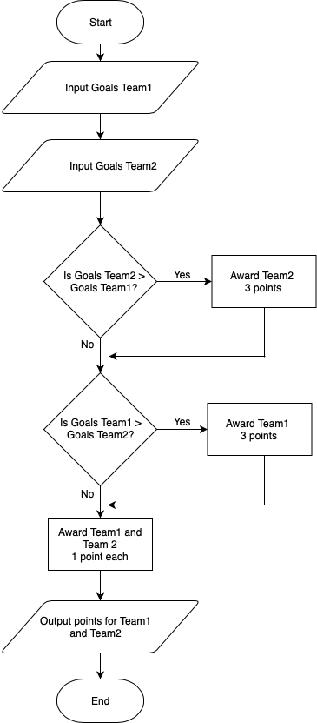

Using the flow chart above, what would be the outputs for the following score lines?

Team 1 – 3 Team 2 – 1

Output ___________

Team 1 – 2 Team 2 – 2

Output ___________

Team 1 – 1 Team 2 – 1

Output ____________